ECA5801-IOE AND AI DRIVEN SYSTEM
EXPERIMENT 6:
- Simulation and Performance Evaluation of People–Process–Data–Things IoE Framework using Edge/Fog-to-Cloud Pipeline with MQTT, Node-RED.

PROGRAM CODE:
import numpy as np
import pandas as pd
import matplotlib.pyplot as plt

np.random.seed(42)

# Simulation parameters
NUM_MESSAGES = 1000
MESSAGE_SIZE_BYTES = 1024
SIMULATION_TIME = 60

# P-P-D-T framework
print("PEOPLE-PROCESS-DATA-THINGS IoE FRAMEWORK")
print("=" * 50)
print("People: Users, Operators, Administrators")
print("Process: Monitoring, Analysis, Decision Making")
print("Data: Sensor readings and MQTT messages")
print("Things: IoE sensors and connected devices")

# Edge, Fog and Cloud parameters
architectures = {
"Edge": {
"network_delay": 5,
"processing_time": 3,
"packet_loss": 0.01
},
"Fog": {
"network_delay": 15,
"processing_time": 6,
"packet_loss": 0.02
},
"Cloud": {
"network_delay": 50,
"processing_time": 12,
"packet_loss": 0.03
}
}

results = []

for architecture, params in architectures.items():

network_delay = np.maximum(
np.random.normal(
params["network_delay"],
params["network_delay"] * 0.15,
NUM_MESSAGES
),
0.1
)

processing_time = np.maximum(
np.random.normal(
params["processing_time"],
params["processing_time"] * 0.2,
NUM_MESSAGES
),
0.1
)

total_latency = network_delay + processing_time

delivered = np.random.random(NUM_MESSAGES) >= params["packet_loss"]

successful_messages = np.sum(delivered)
lost_messages = NUM_MESSAGES - successful_messages

average_latency = (
np.mean(total_latency[delivered])
if successful_messages > 0 else 0
)

throughput = (
successful_messages * MESSAGE_SIZE_BYTES * 8
) / SIMULATION_TIME

reliability = (successful_messages / NUM_MESSAGES) * 100

average_processing = np.mean(processing_time)

results.append({
"Architecture": architecture,
"Network Delay (ms)": np.mean(network_delay),
"Processing Time (ms)": average_processing,
"End-to-End Latency (ms)": average_latency,
"Throughput (bps)": throughput,
"Reliability (%)": reliability,
"Messages Delivered": successful_messages,
"Messages Lost": lost_messages
})

df = pd.DataFrame(results)

print("\nSIMULATION RESULTS")
display(df.round(3))

df.to_csv("experiment_a_results.csv", index=False)

# Graph 1: Latency
plt.figure(figsize=(8, 5))
plt.bar(df["Architecture"], df["End-to-End Latency (ms)"])
plt.title("Edge, Fog and Cloud Latency Comparison")
plt.xlabel("Architecture")
plt.ylabel("Latency (ms)")
plt.grid(axis="y", alpha=0.3)
plt.show()

# Graph 2: Throughput
plt.figure(figsize=(8, 5))
plt.bar(df["Architecture"], df["Throughput (bps)"])
plt.title("Edge, Fog and Cloud Throughput Comparison")
plt.xlabel("Architecture")
plt.ylabel("Throughput (bps)")
plt.grid(axis="y", alpha=0.3)
plt.show()

# Graph 3: Reliability
plt.figure(figsize=(8, 5))
plt.bar(df["Architecture"], df["Reliability (%)"])
plt.title("Edge, Fog and Cloud Reliability Comparison")
plt.xlabel("Architecture")
plt.ylabel("Reliability (%)")
plt.ylim(0, 100)
plt.grid(axis="y", alpha=0.3)
plt.show()

# Graph 4: Processing Time
plt.figure(figsize=(8, 5))
plt.bar(df["Architecture"], df["Processing Time (ms)"])
plt.title("Edge, Fog and Cloud Processing Time")
plt.xlabel("Architecture")
plt.ylabel("Processing Time (ms)")
plt.grid(axis="y", alpha=0.3)
plt.show()

# P-P-D-T data flow
stages = ["People", "Process", "Data", "Things", "Edge/Fog", "Cloud"]

plt.figure(figsize=(12, 3))
positions = np.arange(len(stages))

plt.plot(positions, np.zeros(len(stages)), marker="o")

for i, stage in enumerate(stages):
plt.text(i, 0.03, stage, ha="center")

for i in range(len(stages) - 1):
plt.annotate(
"",
xy=(i + 0.9, 0),
xytext=(i + 0.1, 0),
arrowprops=dict(arrowstyle="->")
)

plt.title("P-P-D-T IoE Data Flow")
plt.axis("off")
plt.show()

print("\nExperiment (a) completed successfully.")
print("Results saved to experiment_a_results.csv")

OUTPUT:
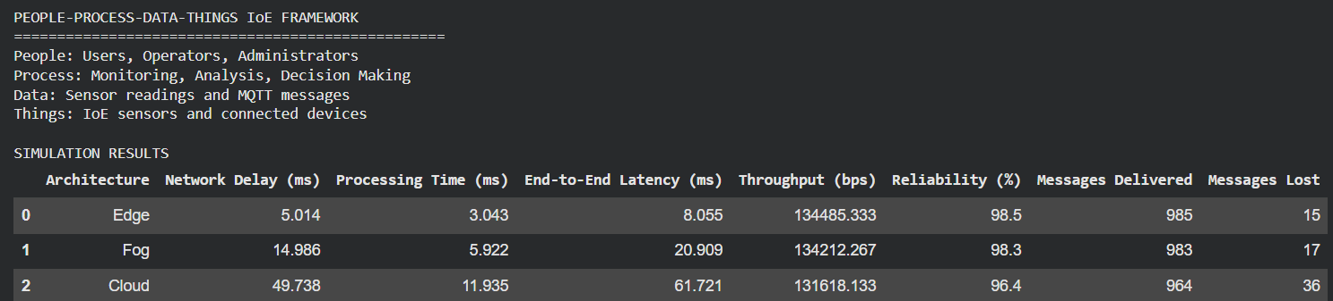

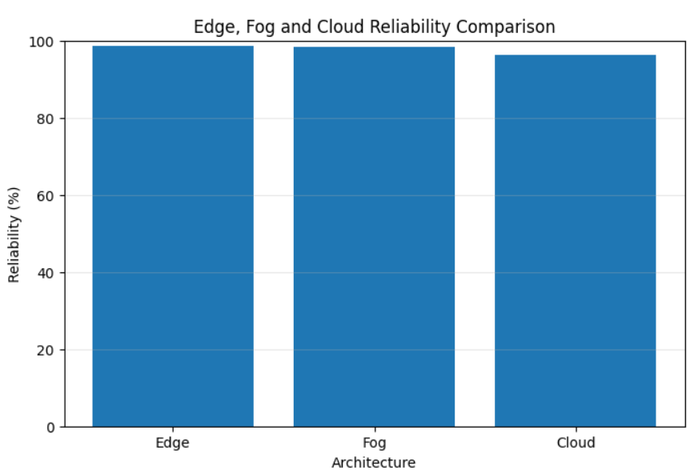

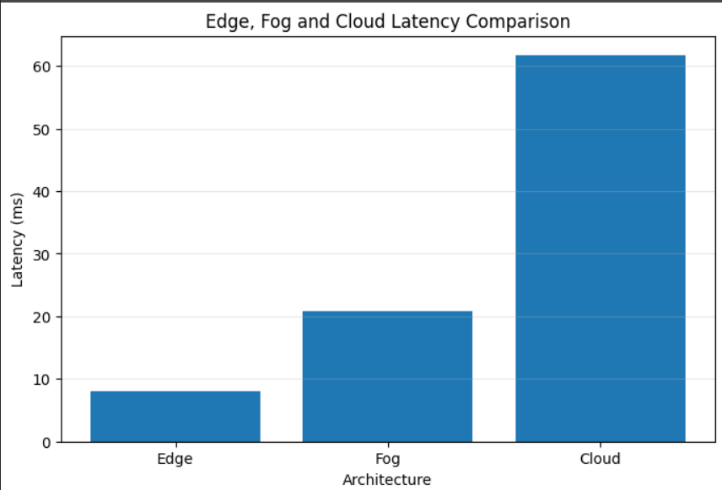
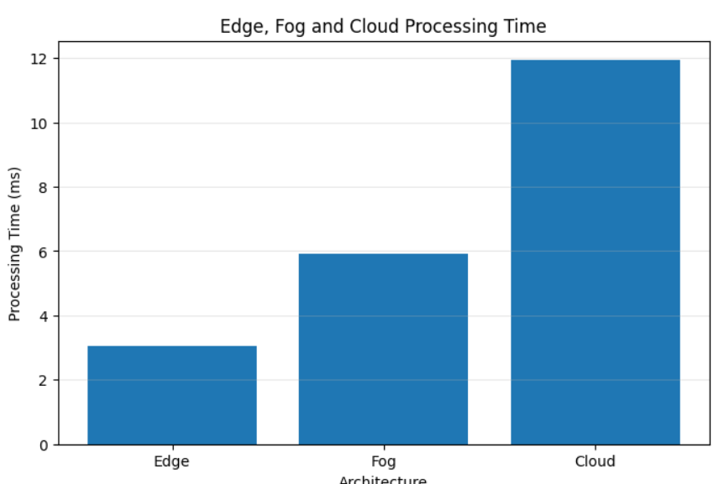

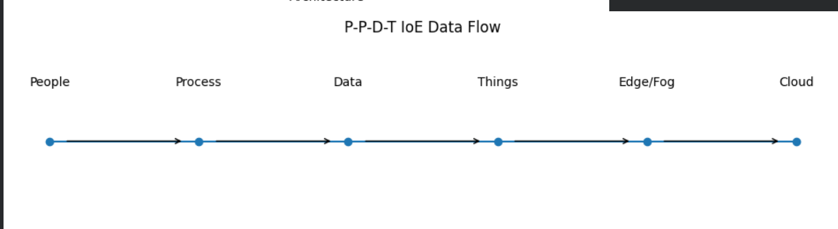

EXPERIMENT 6:
- Benchmarking of 5G/6G Communication for IoE Applications based on Throughput, Latency, Reliability and Energy Efficiency

PROGRAM CODE:
import numpy as np
import pandas as pd
import matplotlib.pyplot as plt

np.random.seed(42)

# Simulation parameters
NUM_MESSAGES = 2000
MESSAGE_SIZE_BYTES = 1500
SIMULATION_TIME = 60
NUM_TRIALS = 10

# Illustrative simulation profiles, not actual measured specifications
networks = {
"5G": {
"bandwidth_mbps": 100,
"latency_ms": 20,
"jitter_ms": 4,
"packet_loss": 0.02,
"power_watts": 5
},
"6G Hypothetical": {
"bandwidth_mbps": 1000,
"latency_ms": 5,
"jitter_ms": 1,
"packet_loss": 0.005,
"power_watts": 8
}
}

results = []

for network_name, params in networks.items():

for trial in range(1, NUM_TRIALS + 1):

latency = np.maximum(
np.random.normal(
params["latency_ms"],
params["jitter_ms"],
NUM_MESSAGES
),
0.1
)

delivered = np.random.random(NUM_MESSAGES) >= params["packet_loss"]

successful_messages = np.sum(delivered)

delivered_bits = (
successful_messages * MESSAGE_SIZE_BYTES * 8
)

throughput_mbps = (
delivered_bits / SIMULATION_TIME
) / 1_000_000

average_latency = (
np.mean(latency[delivered])
if successful_messages > 0 else 0
)

reliability = (
successful_messages / NUM_MESSAGES
) * 100

energy_joules = params["power_watts"] * SIMULATION_TIME

energy_efficiency = delivered_bits / energy_joules

results.append({
"Network": network_name,
"Trial": trial,
"Latency (ms)": average_latency,
"Throughput (Mbps)": throughput_mbps,
"Reliability (%)": reliability,
"Power (W)": params["power_watts"],
"Energy (J)": energy_joules,
"Energy Efficiency (bits/J)": energy_efficiency
})

df = pd.DataFrame(results)

print("5G/6G SIMULATION RESULTS")
display(df.round(4))

df.to_csv("experiment_b_trial_results.csv", index=False)

# Calculate average performance across trials
summary = df.groupby("Network").agg({
"Latency (ms)": "mean",
"Throughput (Mbps)": "mean",
"Reliability (%)": "mean",
"Energy Efficiency (bits/J)": "mean"
}).reset_index()

print("\nAVERAGE PERFORMANCE COMPARISON")
display(summary.round(4))

summary.to_csv("experiment_b_summary.csv", index=False)

# Graph 1: Throughput
plt.figure(figsize=(8, 5))
plt.bar(summary["Network"], summary["Throughput (Mbps)"])
plt.title("5G vs Hypothetical 6G Throughput")
plt.xlabel("Network")
plt.ylabel("Throughput (Mbps)")
plt.grid(axis="y", alpha=0.3)
plt.show()

# Graph 2: Latency
plt.figure(figsize=(8, 5))
plt.bar(summary["Network"], summary["Latency (ms)"])
plt.title("5G vs Hypothetical 6G Latency")
plt.xlabel("Network")
plt.ylabel("Latency (ms)")
plt.grid(axis="y", alpha=0.3)
plt.show()

# Graph 3: Reliability
plt.figure(figsize=(8, 5))
plt.bar(summary["Network"], summary["Reliability (%)"])
plt.title("5G vs Hypothetical 6G Reliability")
plt.xlabel("Network")
plt.ylabel("Reliability (%)")
plt.ylim(0, 100)
plt.grid(axis="y", alpha=0.3)
plt.show()

# Graph 4: Energy Efficiency
plt.figure(figsize=(8, 5))
plt.bar(
summary["Network"],
summary["Energy Efficiency (bits/J)"
]
)
plt.title("5G vs Hypothetical 6G Energy Efficiency")
plt.xlabel("Network")
plt.ylabel("Energy Efficiency (bits/J)")
plt.grid(axis="y", alpha=0.3)
plt.show()

print("\nExperiment (b) completed successfully.")
print("Results saved to experiment_b_trial_results.csv")
print("Summary saved to experiment_b_summary.csv")

OUTPUT:
